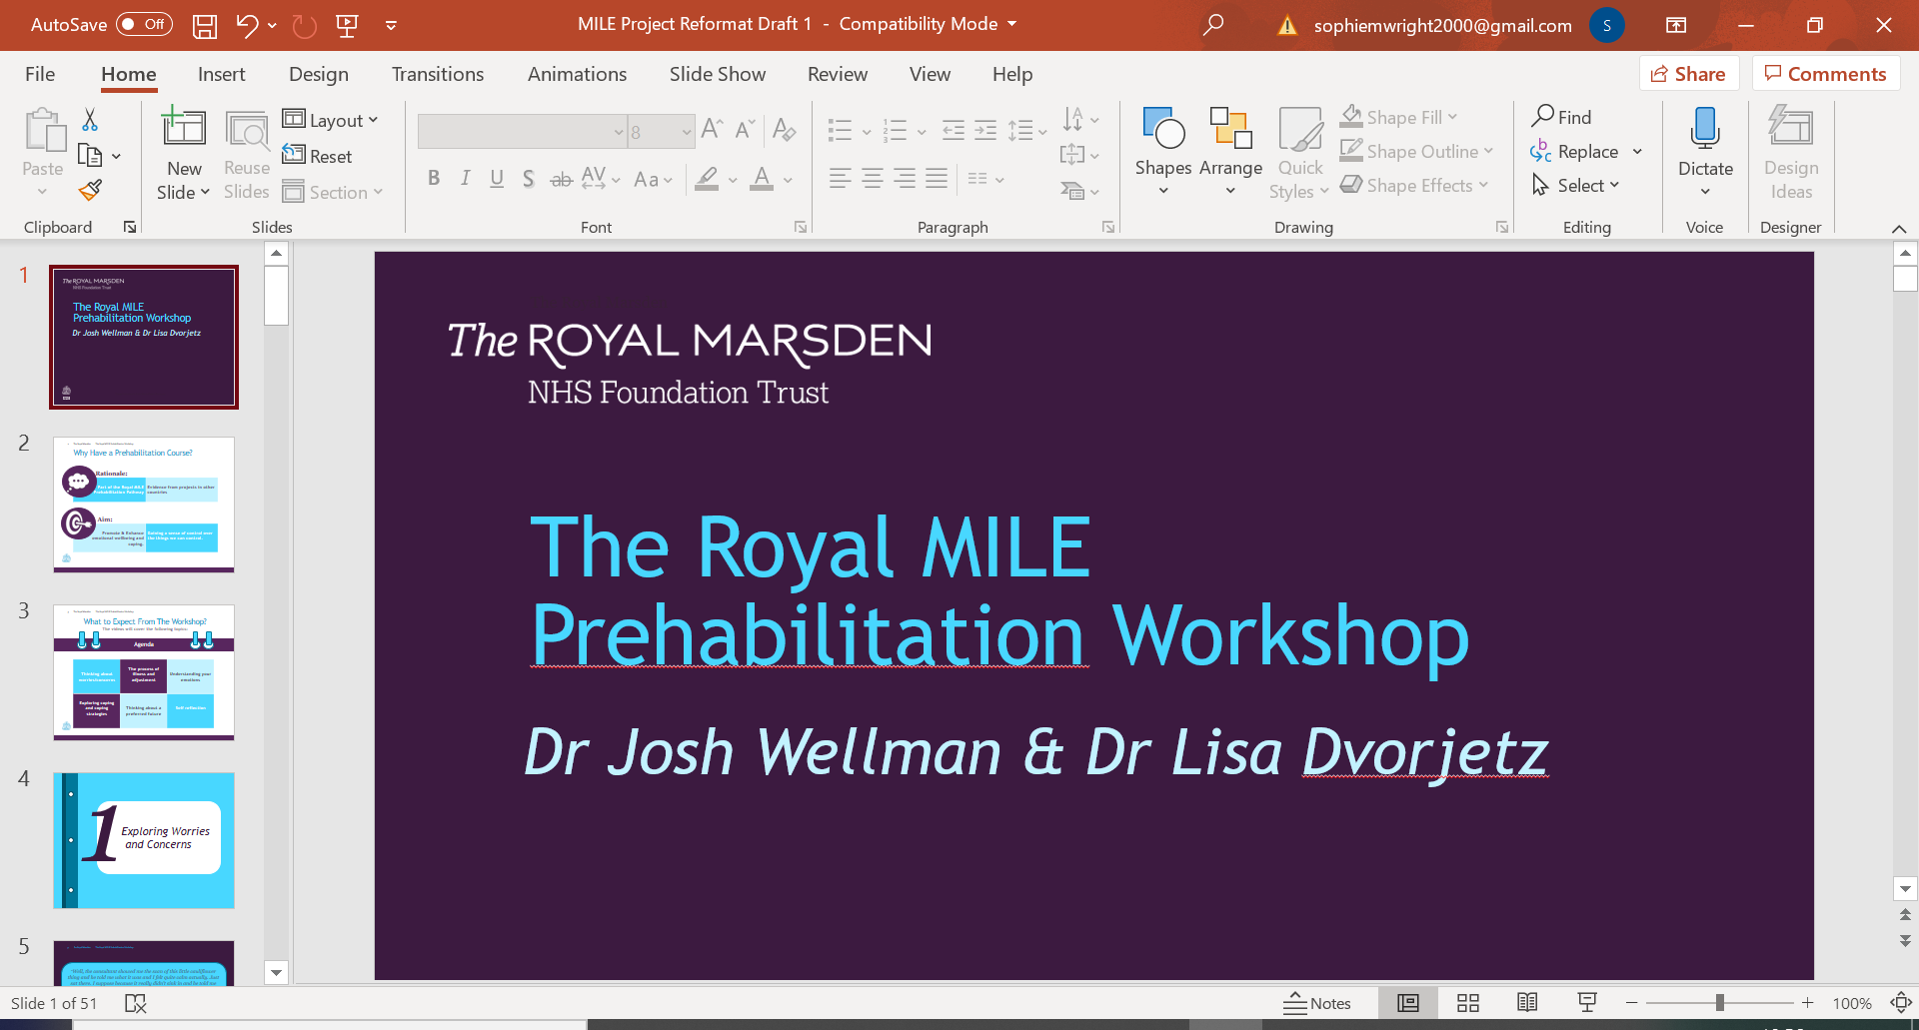

|  |
| --- |
|  |
| *MILE Prehabilitation* |
| *Video 9: Ending Reflections* |

|  |
| --- |
|  |

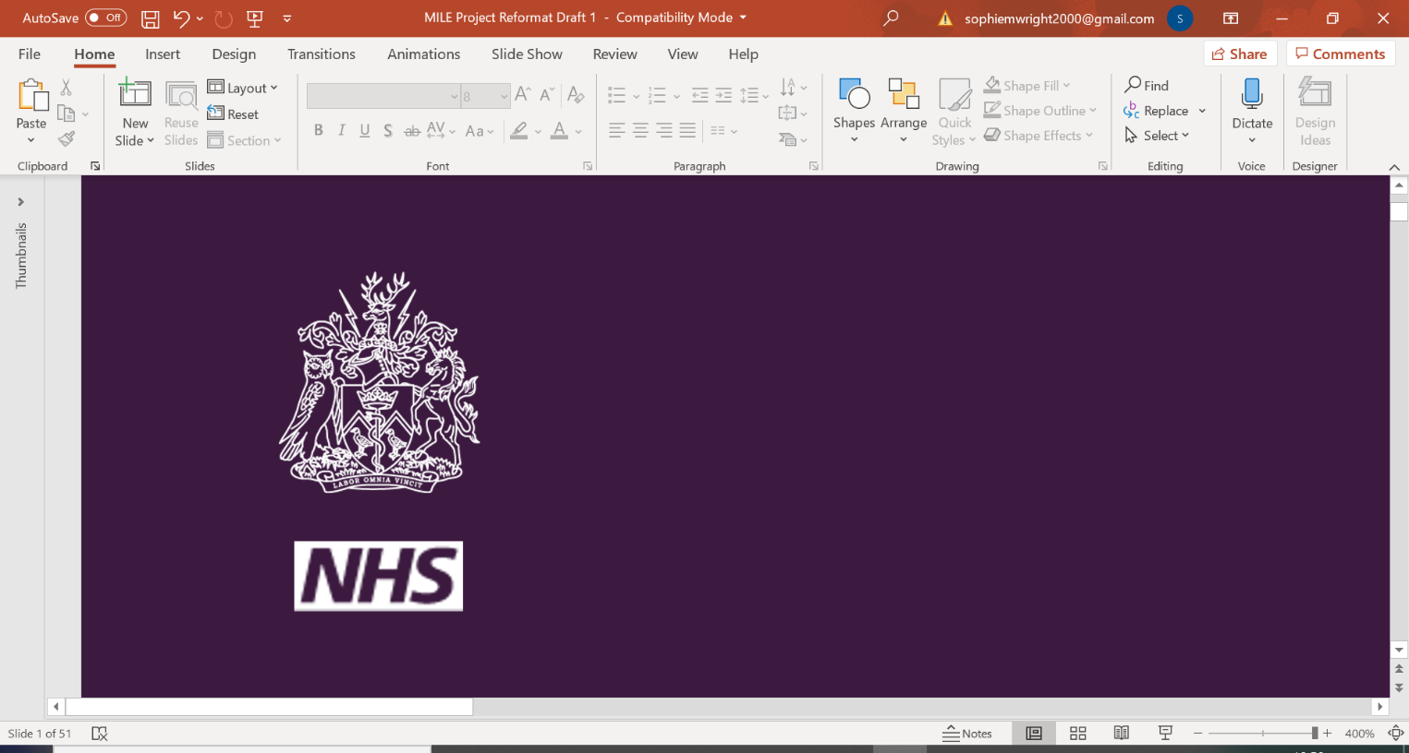



*Ending Reflections*

Take a few minutes to think about the below questions. We’d like to invite you to write down your reflections as you may want to come back to them at a later date.

**What I found useful from these videos was…**

**What useful thing(s) will I take forward and use in my daily life?**

O

*Notes*