MILE Prehabilitation
Workshop 8: Continuing on with life
Your Preferred Future – Part 1

Just suppose… after watching this video today you go about the rest of your day as you normally do, you go to bed at the usual time and let’s just say that when you wake up in the morning, things feel better.
What’s the first thing that you would notice about yourself after you wake up? What’s the next thing you would notice? What would you be thinking? What would you be doing? What would other significant people (or pets) notice about you? How would they respond? What’s the next thing you would do?
Spend some time mapping out your better day… imagining that momentum stays with you throughout the day. Try to create as full a picture of the better day as possible, taking note of what you would be doing, how you would be feeling and what difference it would make to you and people important to you.
Now imagine that the momentum continues after this better day.
What difference would this better day make in the coming days?
What would be different in the coming weeks?

Your Preferred Future - Notepad

If you would like to jot down your thoughts, you can use the space below.

Your Preferred Future – Part 2

Holding your preferred future in mind, please can you:

- Think back to the last time some aspects of this better day last happened, no matter how small. Try to think about a specific example or examples, write down some details about this below.
- How did you make it happen?
- What would it take to do it again?
- Who is there supporting you? Who (if anyone) would you ask for support?

Pause the video now to think this through….

Your Preferred Future - Notepad

If you would like to jot down your thoughts, you can use the space below.

Scaling Your Preferred Future – Part 3

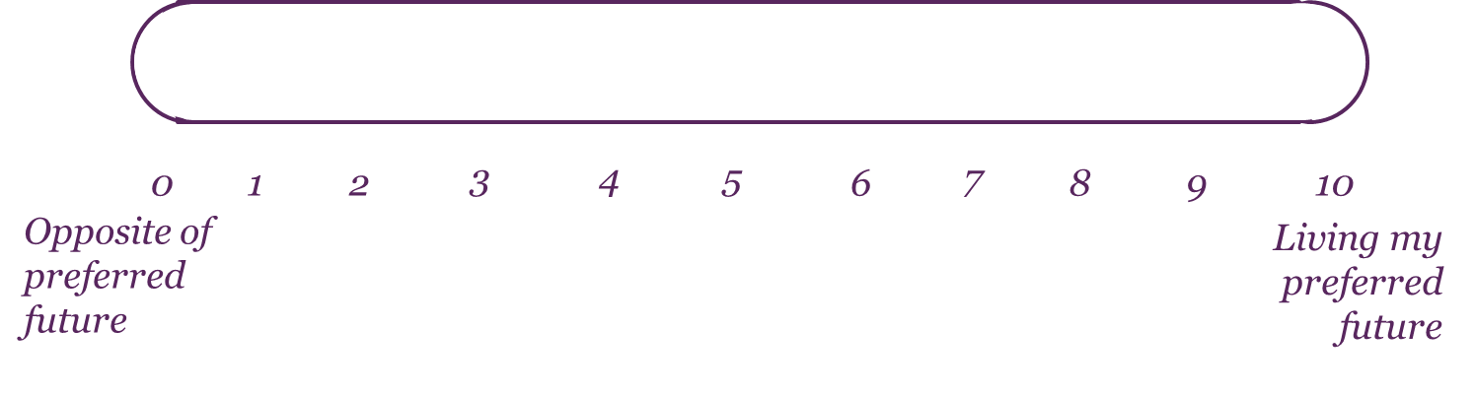

Think back to the last time some aspects of this better day last happened, no matter how small. Try to think about a specific example or instance. How did you make it happen? What would it take to do it again?

Using the scale above, with ten representing that you are living your preferred future and 0 being the complete opposite, rate where you would be on the scale at the moment:

- If you have rated yourself anything above 0 – ask yourself what makes you that score out of 10, as opposed to being a 0 out of ten. For example if you are a 5/10, ask yourself, how come I am at 5 out of 10 as opposed to 0 out of 10? Try to list out ten things that make you 5 right now as opposed to 0.
- If you rated yourself a 0 – Ask yourself – How did you find the strength to make it here today to access this video? How did you stop yourself from falling off the scale completely?

Notes

Scaling Your Preferred Future – Moving Up the Scale – Part 4

If you were to move just one point up the scale, what would you be doing differently, or more of?

Pause the video and try to list five or more things that would be different if you were one point up the scale.
- What would it take to make the changes that you have written down?
- What would be the first small signs of progress?
- If you could make those changes, what difference would it make to you?

Once you have completed this task, you can revisit your preferred future any time that you wish, either to remind yourself of what you are working towards, to note down any further ideas you come up with, any progress you might have made and to think about further steps that you will take to continue to move forward

Notes

