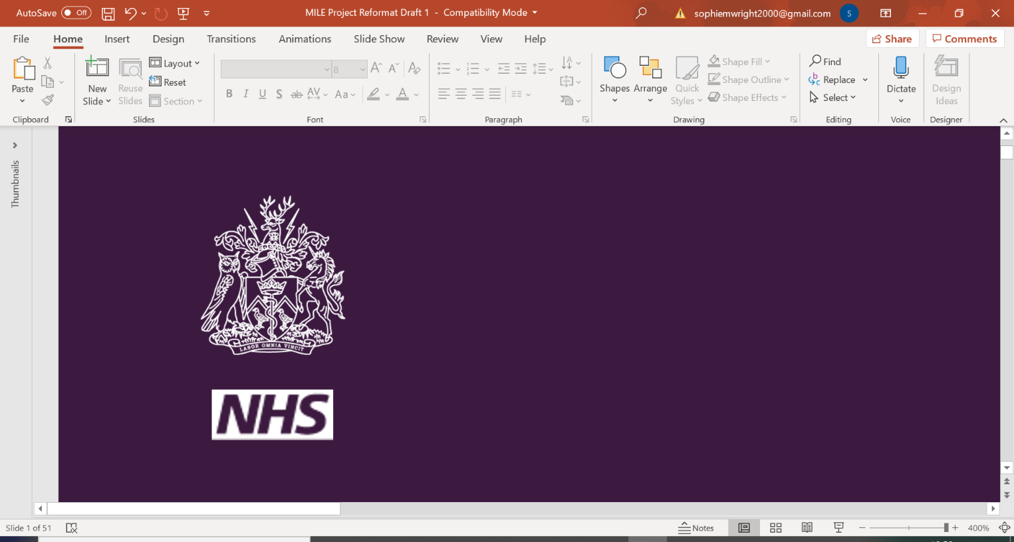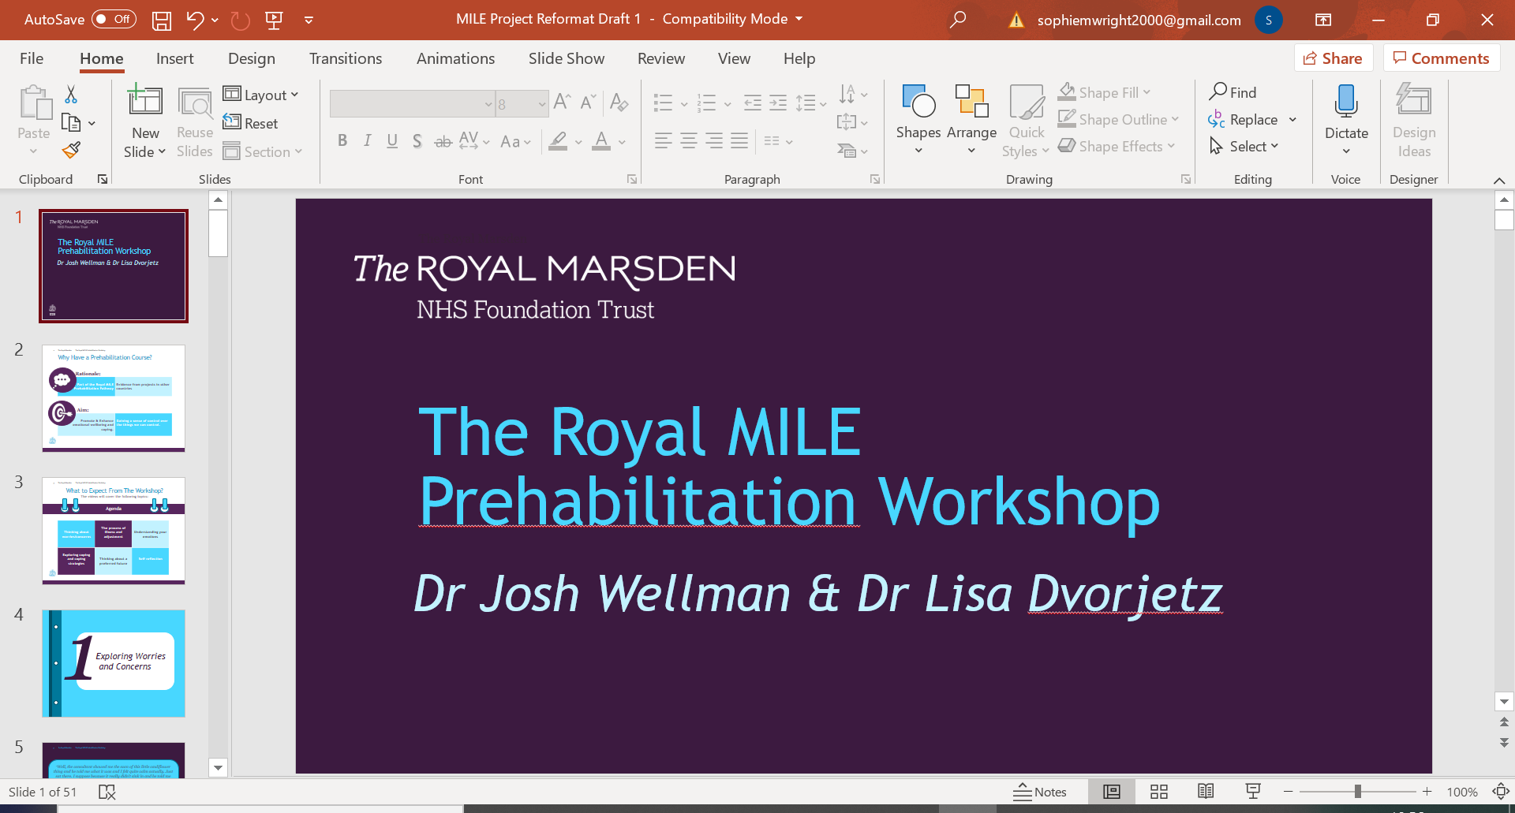

|  |
| --- |
|  |
| *MILE Prehabilitation* |
| *Worksheet 7i: Distraction Techniques* |

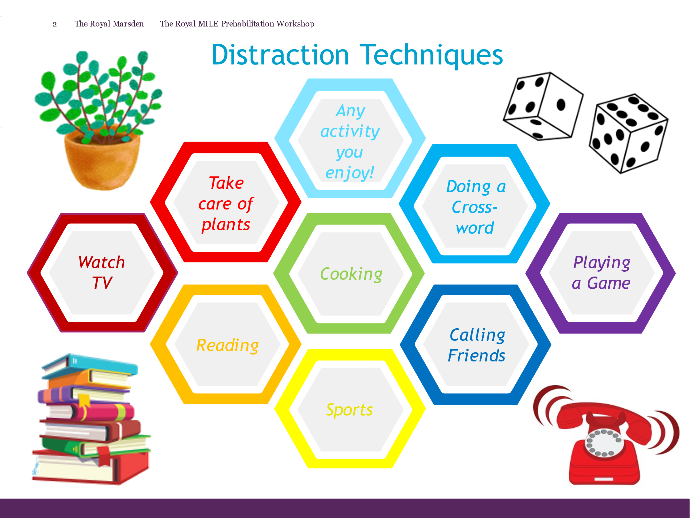

*Notes*