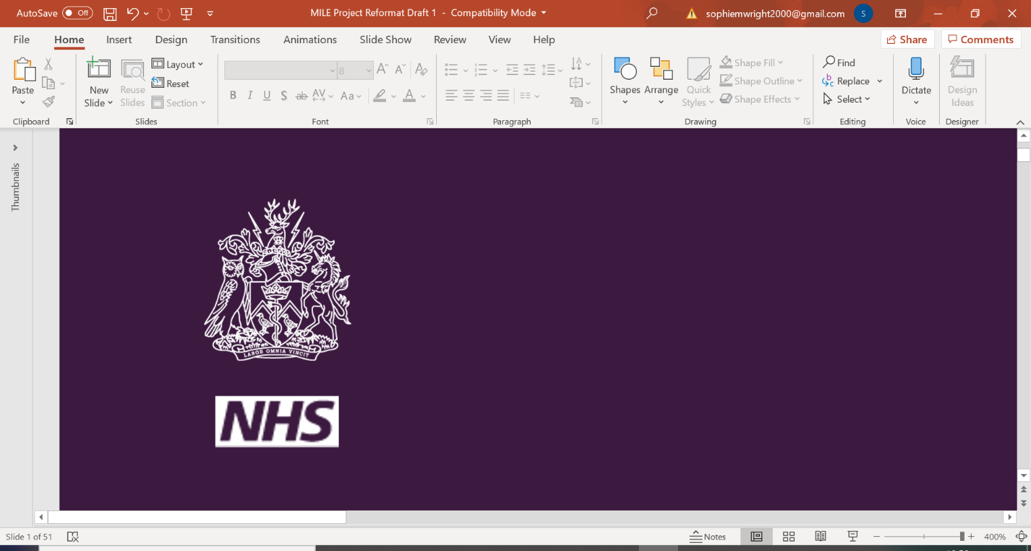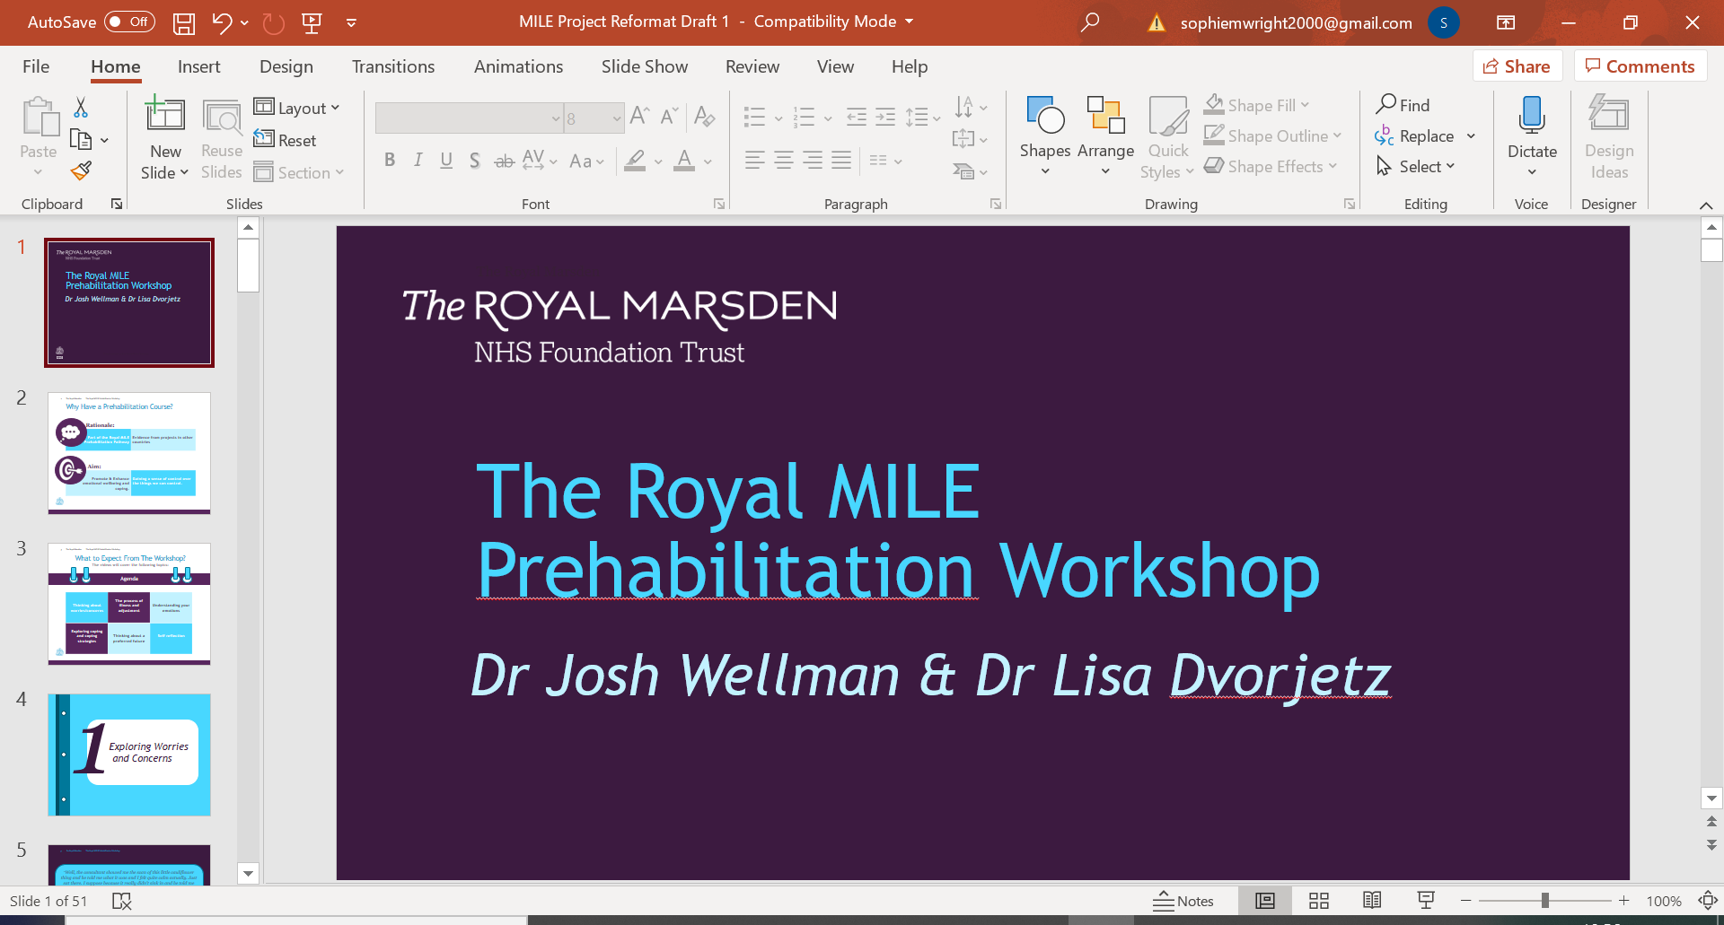

|  |
| --- |
|  |
| *MILE Prehabilitation* |
| *Worksheet 7e: Progressive Muscle Relaxation* |

|  |
| --- |
| *Remember, if it is hurting when you tense your muscles, you are squeezing too hard – this exercise shouldn’t hurt* |

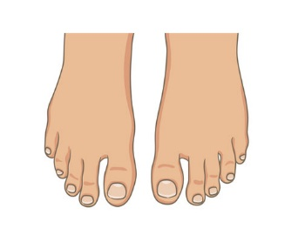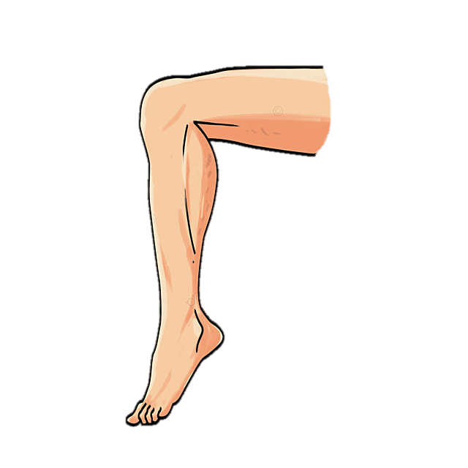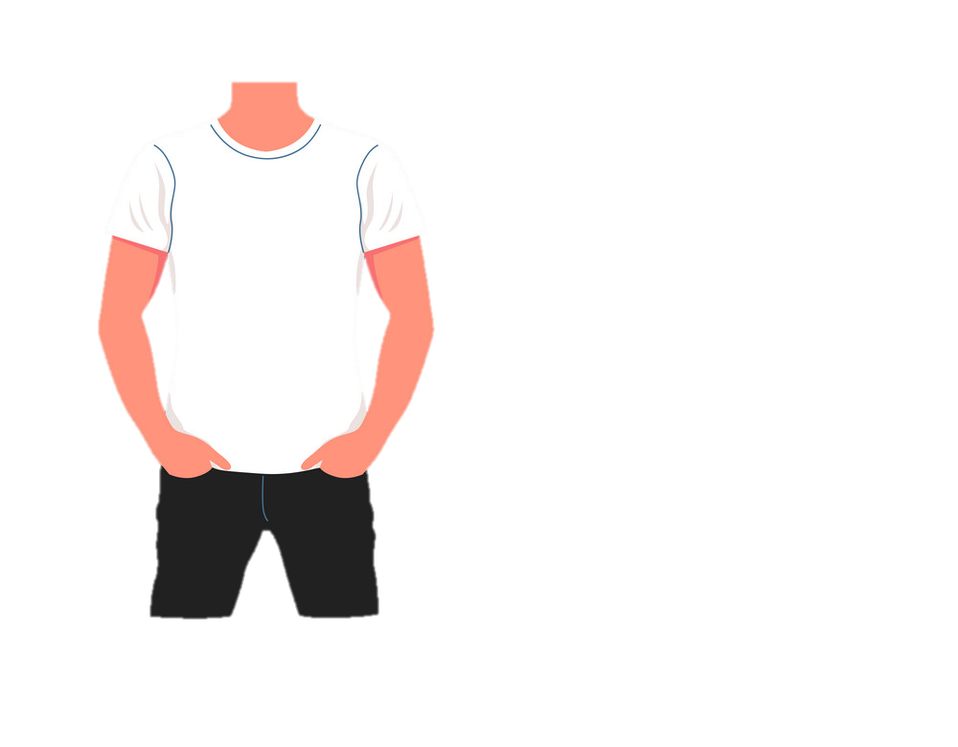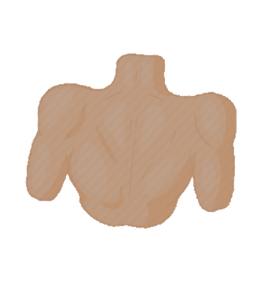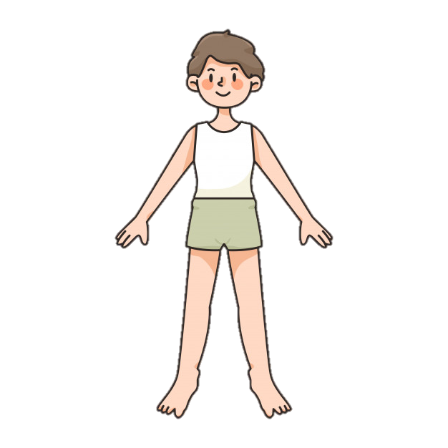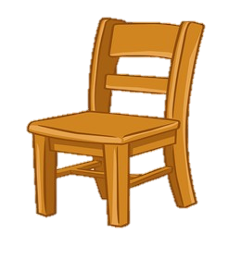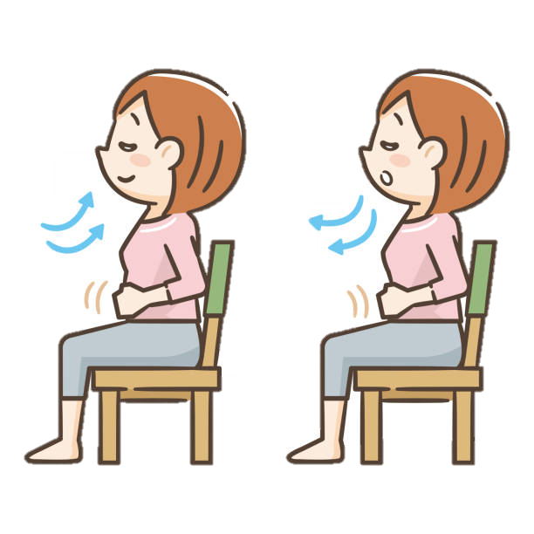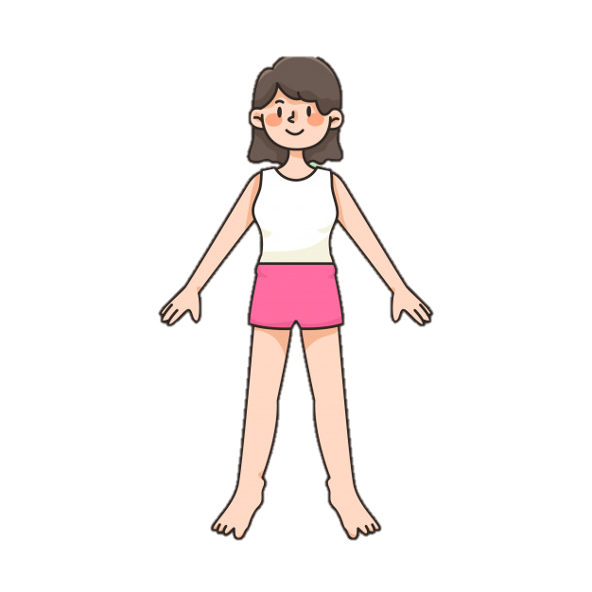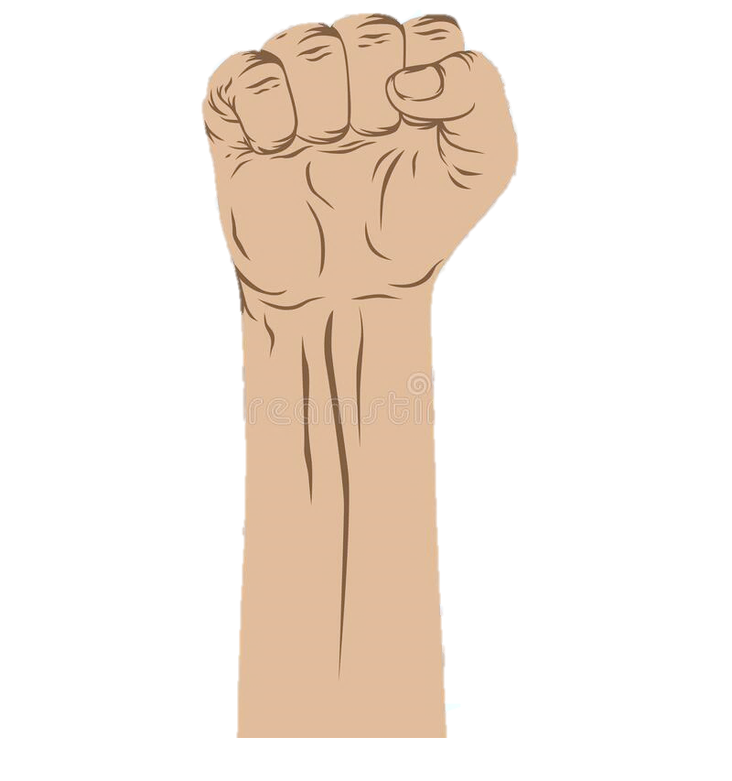

***Progressive Muscle Relaxation***

*Sit back or lie down in a comfortable position. Shut your eyes if comfortable.*

*Take a deep breath. Hold for a few seconds. Release slowly, letting go of tension. Repeat.*

*Tense feet by curling toes and arch of foot. Hold the tension. Release the tension and attend to the feeling of relaxation.*

*Focus on lower legs. Tense calves and hold them, focusing on the tensed feeling. Release the tension and focus on the feeling of relaxation.*

*Tense muscles in pelvis and upper leg by squeezing thighs together. As you release, focus on the feeling of tension leaving your muscles.*

*Tense back muscles by bringing shoulders together behind you. Hold them tightly. Attend to the bodily changes as you relax.*

*Tense stomach and chest by sucking stomach in. Squeeze and hold tension. Release and let body go limp.*

*Tighten the muscles around your eyes and face. Attend to the feeling of relaxation as you release.*

*Tense whole body. Now release, allowing your whole body to go limp. Stretch your muscles slowly and open eyes when ready.*

*Tense arms all the way up from hands to shoulders by making a fist and squeezing up arm. Then release the tension, noticing how your arms feel limp and at ease*

1

2

3

4

5

6

7

8

9

10