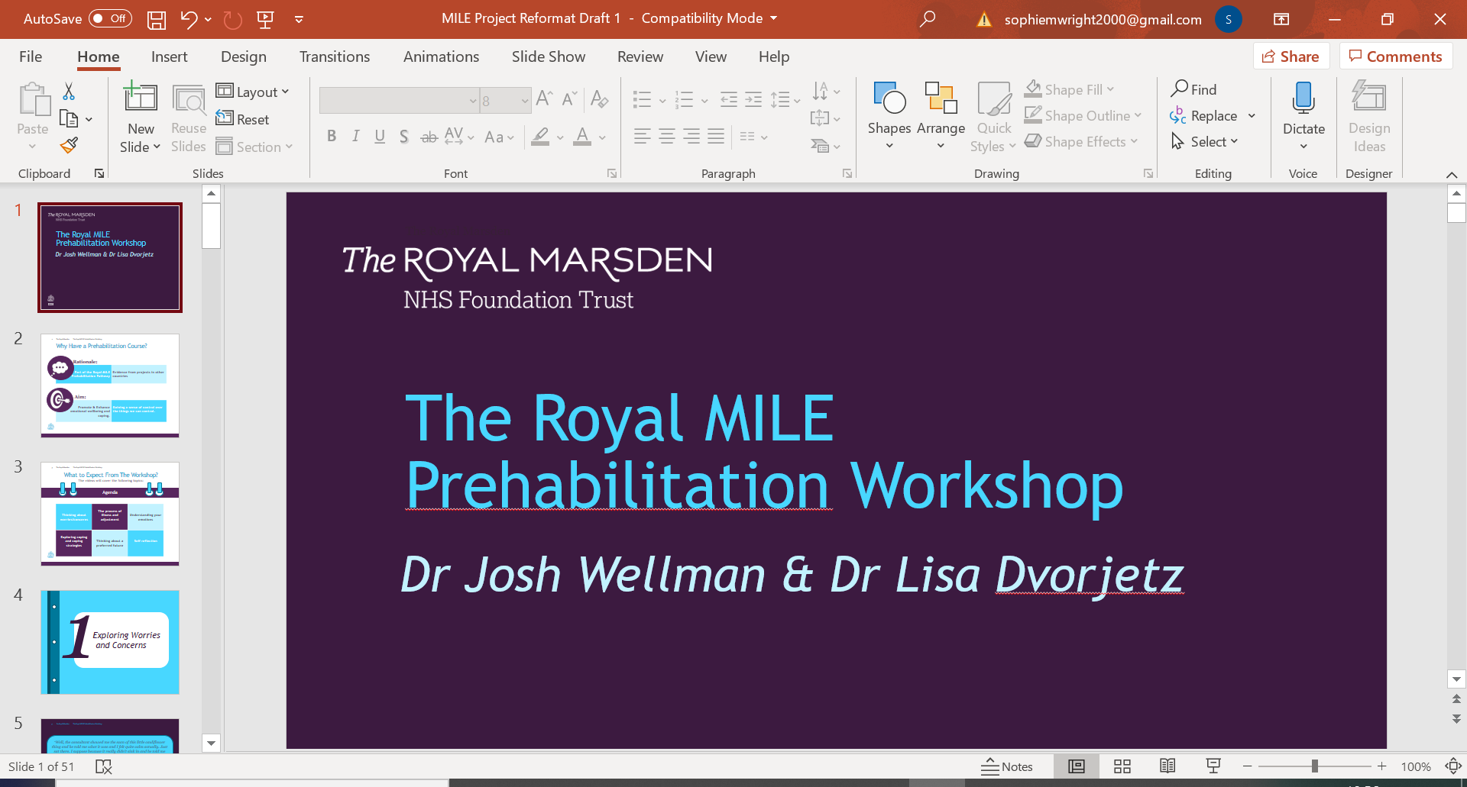

|  |
| --- |
|  |
| *MILE Prehabilitation* |
| *Worksheet 7a: Grounding Exercise 5-4-3-2-1* |

|  |
| --- |
| Grounding Exercise: 5-4-3-2-1 |



*5*

*4*

*3*

*2*

*1*

*5 things you can see*

Look for small details such as a pattern, colour, shape, or the way light reflects off a surface or object.

*4 things you can feel*

Touch anything near you and notice its weight, texture, shape and other physical qualities. Or feel the clothing on your body, the sun on your skin, or the chair you are sitting in.

*3 things you can hear*

Pay special attention to the sounds your mind has tuned out, such as a ticking clock, distant traffic, or trees blowing in the wind.

*2 things you can smell*

Notice smells such as food, drinks, perfume / aftershave, flowers, a candle. Imagine pleasant smells if you are struggling to smell anything.

*1 thing you can taste*

Notice food or drinks you have had, or toothpaste. Imagine a pleasant taste if you are struggling to taste anything.