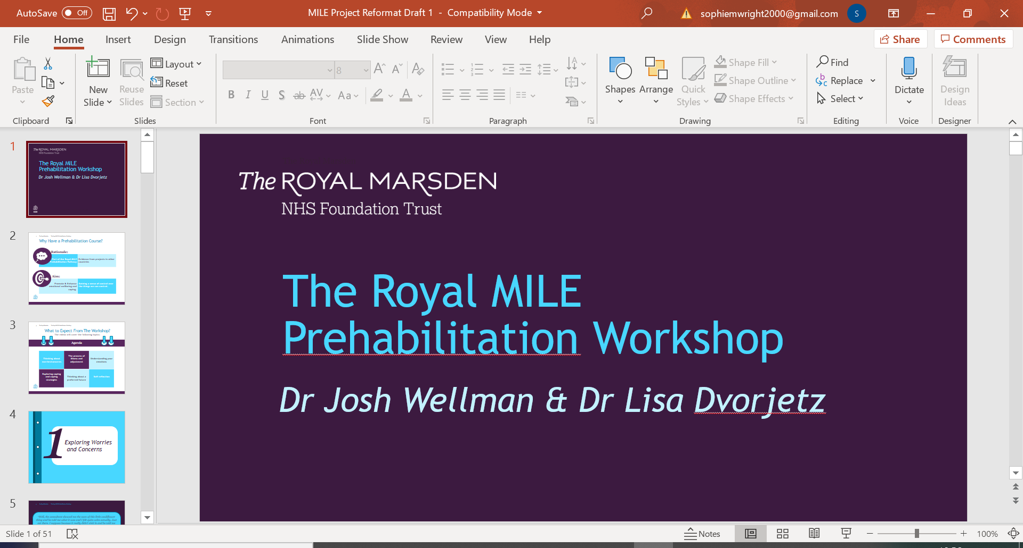

|  |
| --- |
|  |
| *MILE Prehabilitation Workshop Workbook* |
| *Video 7: Additional Coping Strategies* |

|  |
| --- |
|  |

**

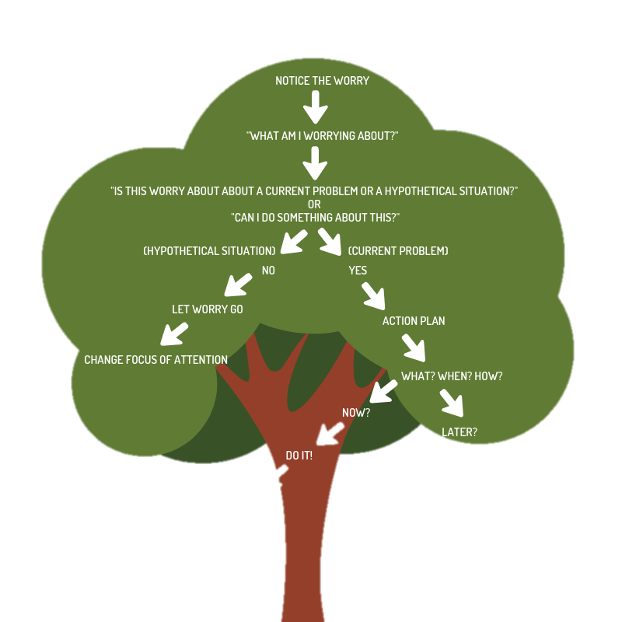

Notice the worry

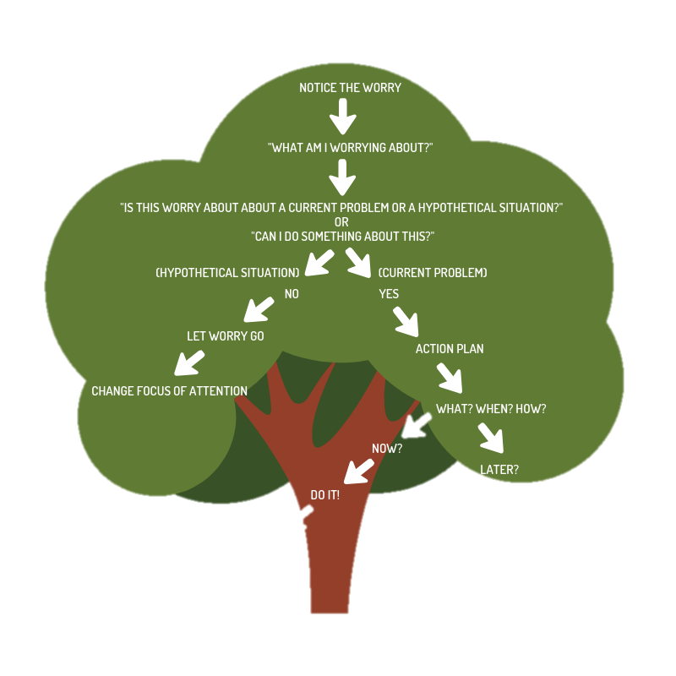

The Worry Tree

Ask: What am I worrying about? (say it aloud or write it down)

“Can I (or someone close to me) do something about this problem?”

Yes

No

[Grounding exercise](https://www.youtube.com/watch?v=8lM8pgMgjEs)

Let the worry go/

coping

Distract yourself (use this as a last resort, as this can increase the worry or create its own problems)

Action plan

[Self-compassion](https://self-compassion.org/category/exercises/)

[Meditation](https://www.getselfhelp.co.uk/meditation.htm)

What? When? How?

[Relaxation](https://www.getselfhelp.co.uk/meditation.htm)

Later?

Now?

Do it!

Schedule it

Any ongoing worry?