MILE Prehabilitation
Worksheet 6: Reviewing your current ways of coping

Using the Coping Scale

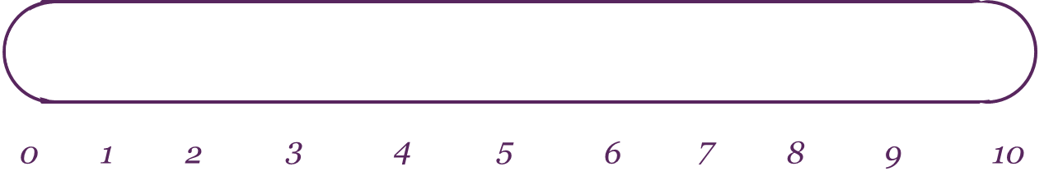

Opposite of coping the best you could
Coping the best you could

Imagine that this scale is representative of how well you are coping with your situation over the past week. Point 10 on the scale represents that you are coping the best you possibly could be and point 0 on the scale is the opposite. Take a moment to mark on the scale how well you are coping right now. Next - set a timer for three minutes.
If you have marked yourself 1 out of 10 or above, spend the three minutes writing down as many reasons that you can think of that makes you this coping score as opposed to a 0 out of 10. For example, if you are a three out of ten, ask yourself- what makes me a three out of ten on the coping scale as opposed to a 0 out of ten. If you can, try to come up with 10 reasons why you are coping this well in the three minutes.
This task requires some thinking and it is important that you take the full three minutes.
If you run out of ideas, ask yourself – What else makes me a three out of ten? Keep asking yourself this question till the time is up.
If you have rated yourself 0 out of 10, I would like you to think about the following questions instead:
What have you been doing to stop things from getting worse? How are you stopping yourself from giving up completely? How did you find the strength to watch this video/ complete this worksheet today?

Notes

Moving up the Scale – Building on Progress

Opposite of coping the best you could
Coping the best you could

Now spend another three minutes considering the following questions:

If you were to move just one point up the coping scale, what would you be doing differently, or more of?
Try to identify at least five things.

Once you have done this, ask yourself:
- What would it take to make those things happen?
- What would be the first small signs that you were heading in that direction?
- If you could make that change, what difference would it make to you in the days, weeks or months ahead?

Once you have completed this task, you can revisit your coping scale any time that you wish, either to remind yourself of what helps, to note down any further ideas you come up with or to think about further steps that you will take to continue to move forward.

- If you were to move just one point up the scale, what would you be doing differently, or more of? What else?
- What would it take to do that? If you could make that change, what difference would it make to you?

Notes

