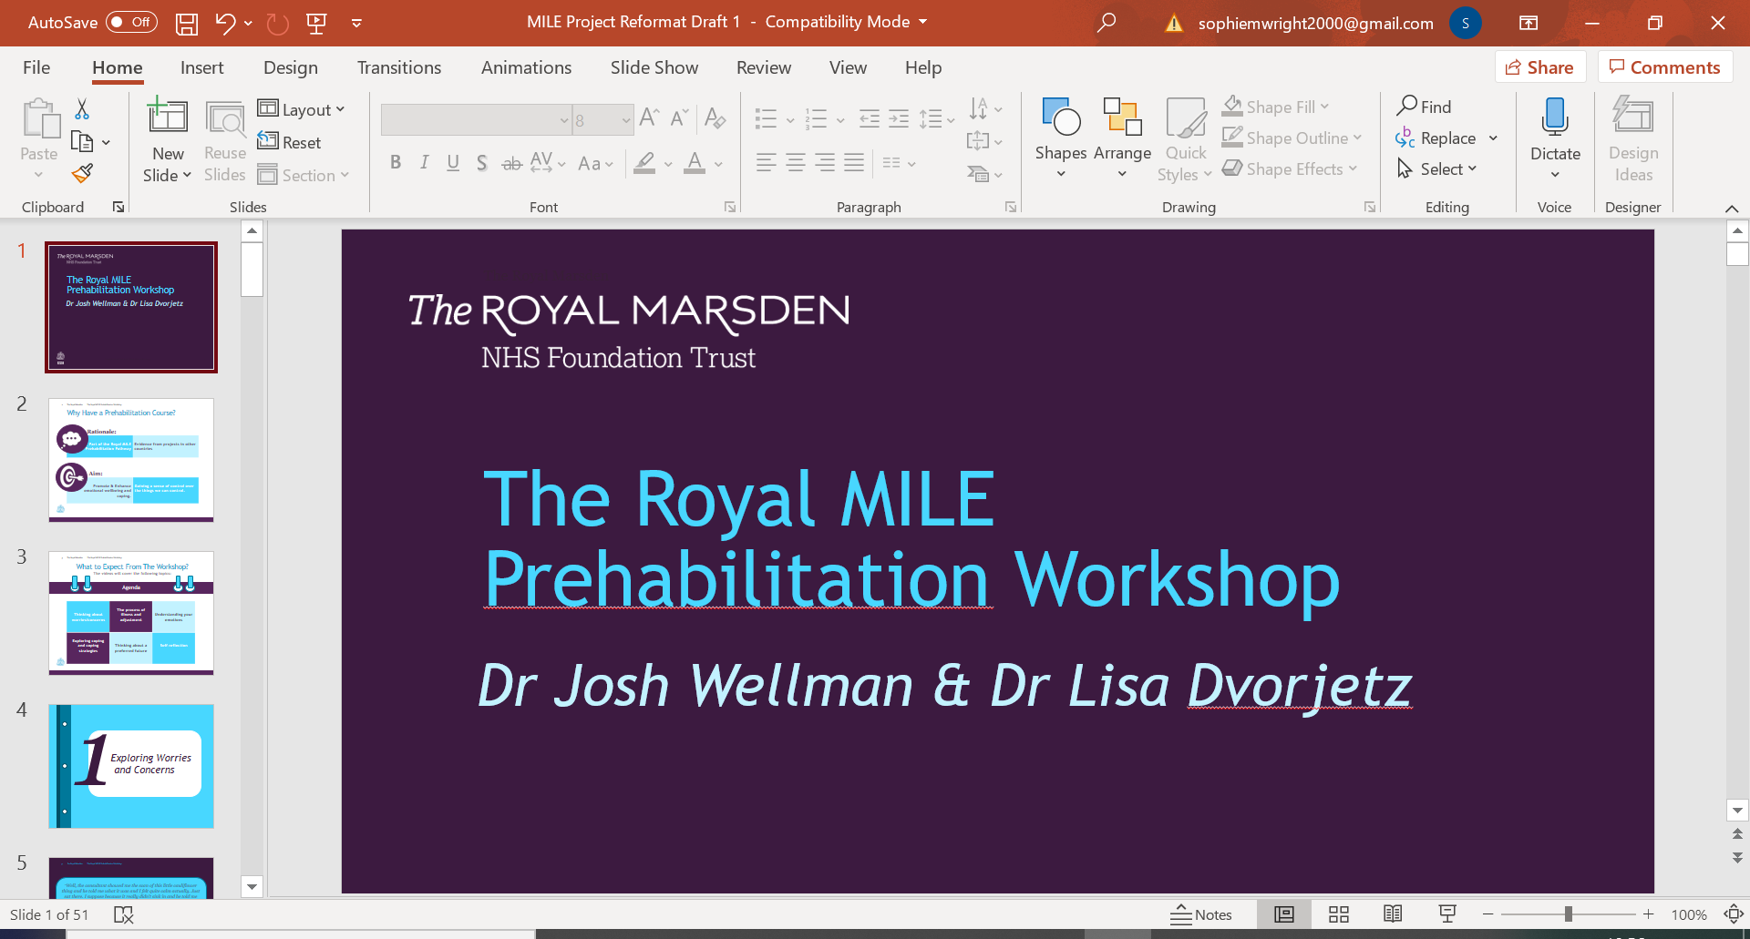

|  |
| --- |
|  |
| *MILE Prehabilitation* |
| *Worksheet 7h: Talking Through Your Concerns* |

|  |
| --- |
|  |

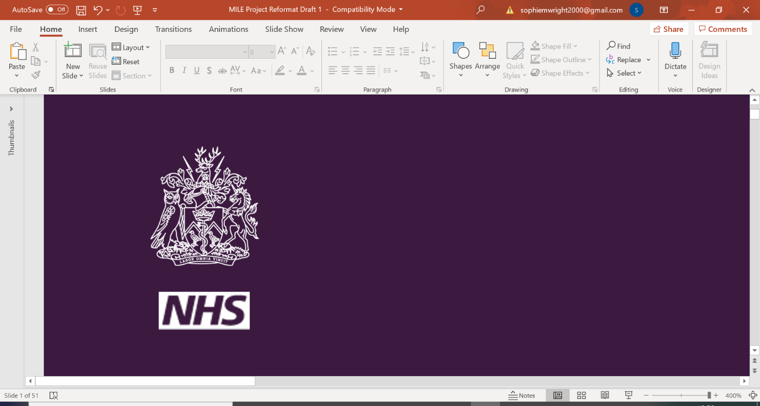

Drawing Out Your Support Network

You can use the diagram on the left as a starting pointing if you wish. Put yourself in the middle circle. Then create a spider diagram of all the people in your life that you might be able to turn to for help or advice, or just to talk to if you had a problem or were feeling 'down'.

You could add in external sources of help, too, such as the Royal Marsden Macmillan Hotline, the Samaritans etc.

*Notes*