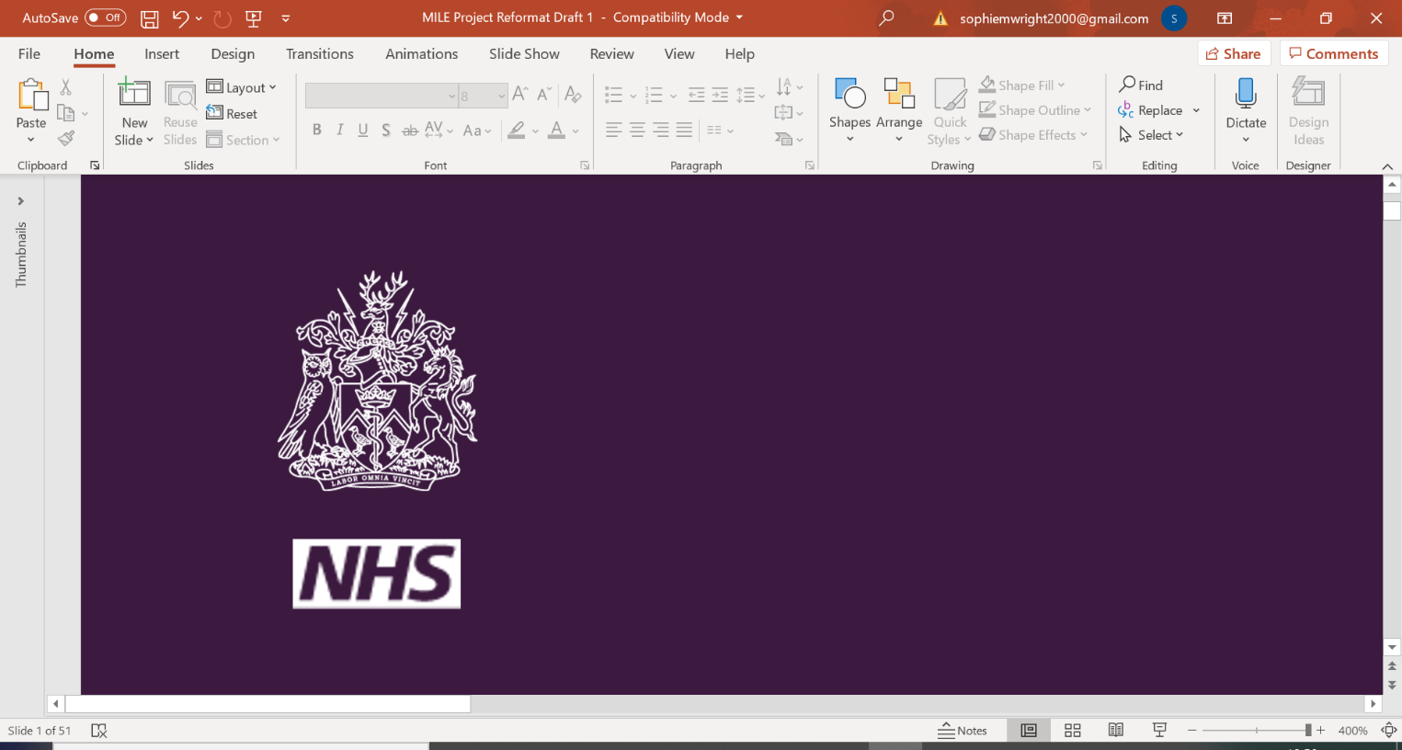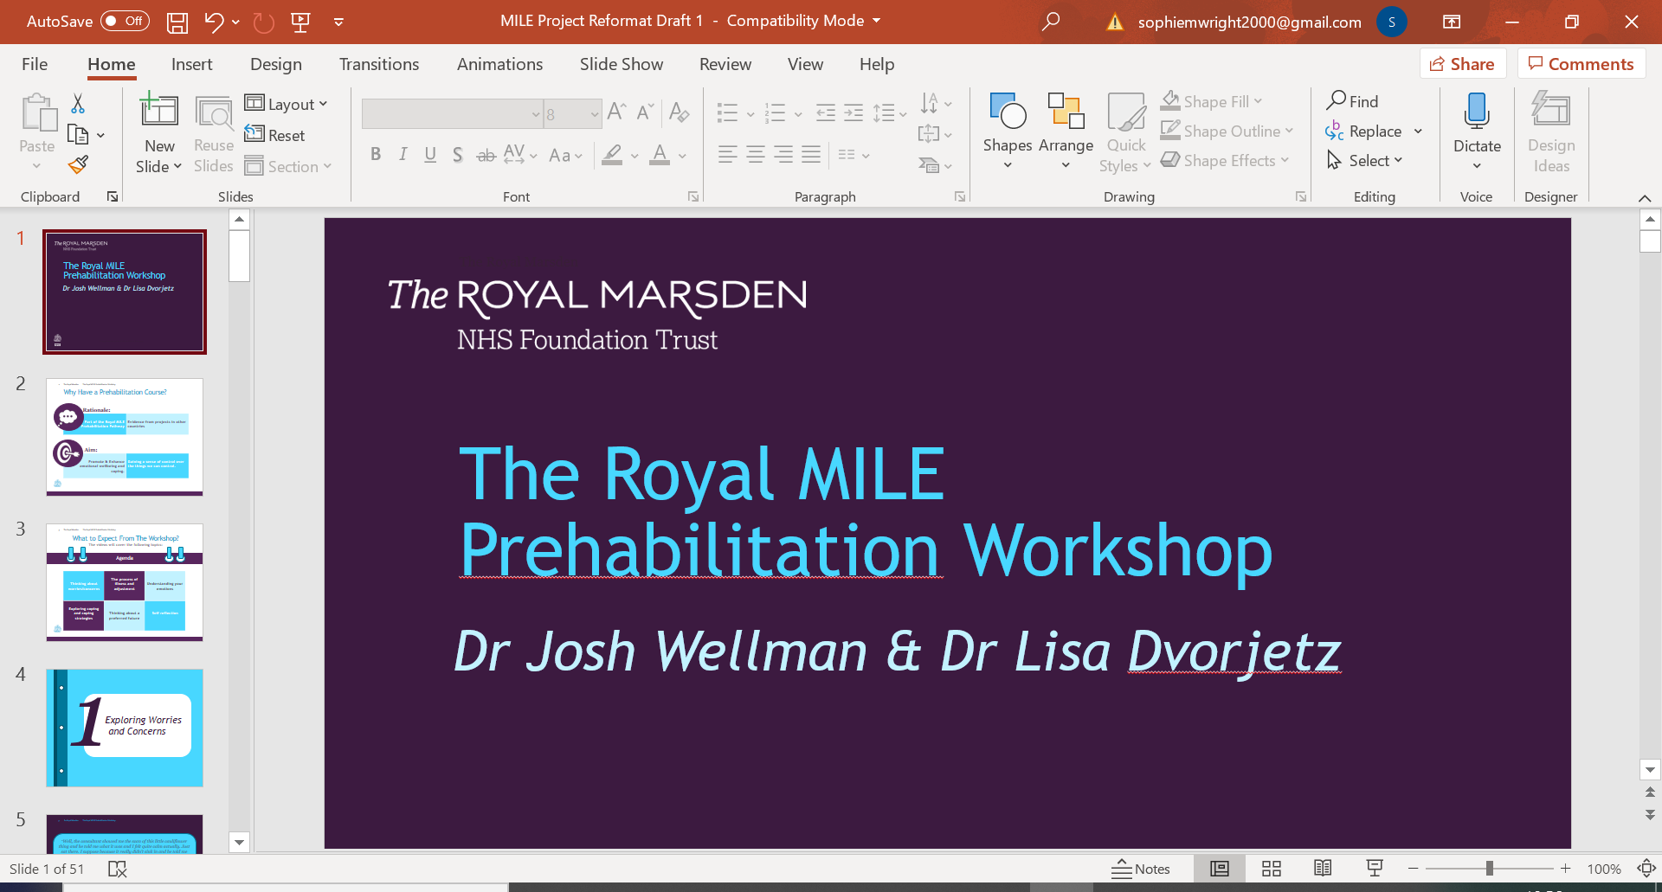

|  |
| --- |
|  |
| *MILE Prehabilitation* |
| *Worksheet 7f: Visual Relaxation* |

|  |
| --- |
|  |

Visual Relaxation



1. Shortly we will continue with a visualisation exercise - Firstly, bring your attention to your breathing. Start by taking a normal breath in, then breathing out for around 4 seconds.
2. Now take a moment to find a comfortable rhythm of breathing for you.
3. Place your arms comfortably by your sides while you are sitting or lying down.
4. Imagine yourself in a calm and peaceful place - this may be real or imagined - a place from the past, somewhere you have visited recently or have always wanted to go. Anywhere.
5. Allow your special place to appear in your mind. Imagine that you are standing at the edge of your place. You know it well and feel safe and at peace here. There are 5 steps leading down to your place. Begin to walk down the steps - when you walk down you will feel more and more relaxed. Walk down the steps… 1 ... 2 ... 3 ... 4 ... 5 and enter your special place.
6. What does it look like? What can you see? Scenery, people, animals, objects?  Think about the shapes, colours, patterns, movement.
7. Are there any noises? People moving or talking, music, animal sounds? Are they loud or soft?
8. Can you touch anything? If so, how does it feel - smooth, rough, hot, warm or cold, firm, soft? How are you feeling - warm, cool?
9. Are there any smells or scents? What are they like?
10. Can you taste anything?

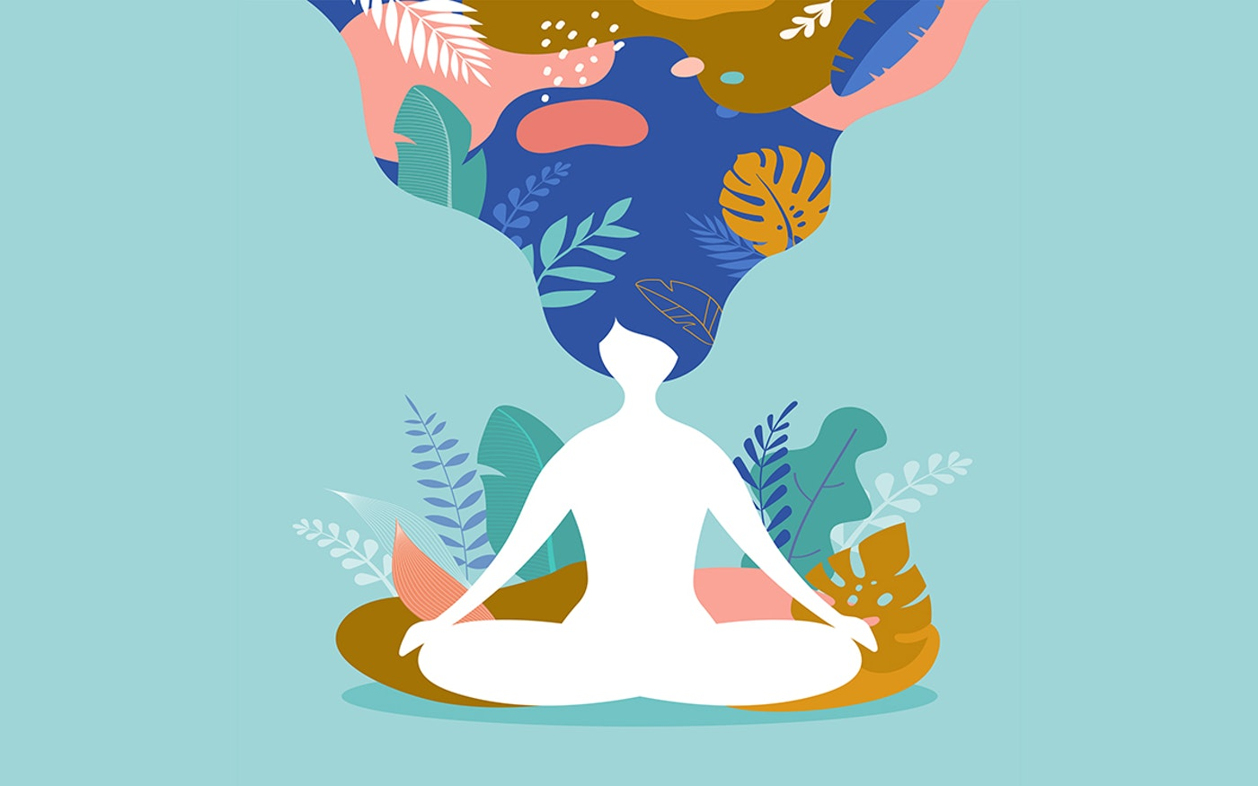

1. Soon it will be time to leave your special place, but before you go remind yourself of all the sights and sounds, and how it feels and smells. Remember that this place will always be here and you can return whenever you wish.
2. In a moment we will begin to climb the steps leading away from your place. With each step the image will become fainter and fainter: 1 ... 2 ... 3 ... 4 ... 5. Allow your place to become fainter and fainter, smaller and smaller, until it eventually disappears.
3. Once again become aware of your breathing. Breathing in through your nose and out through your mouth if this is comfortable. Become aware of your body once again. Feel the contact with the chair or the floor. In your own time, open your eyes and stretch gently.