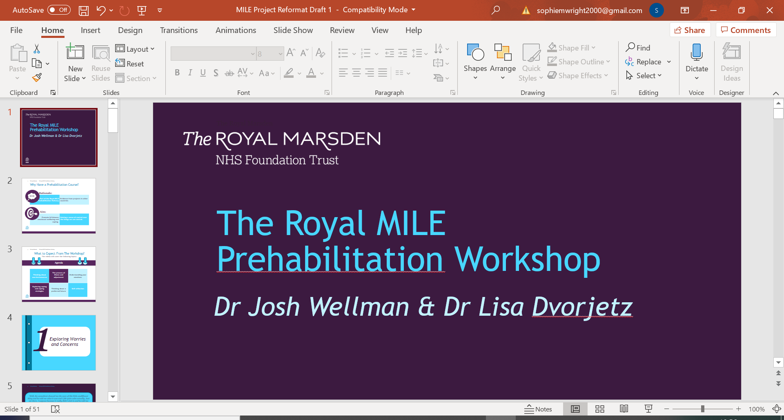

|  |
| --- |
|  |
| *MILE Prehabilitation* |
| *Worksheet 7d: Mindfulness* |

|  |
| --- |
|  |

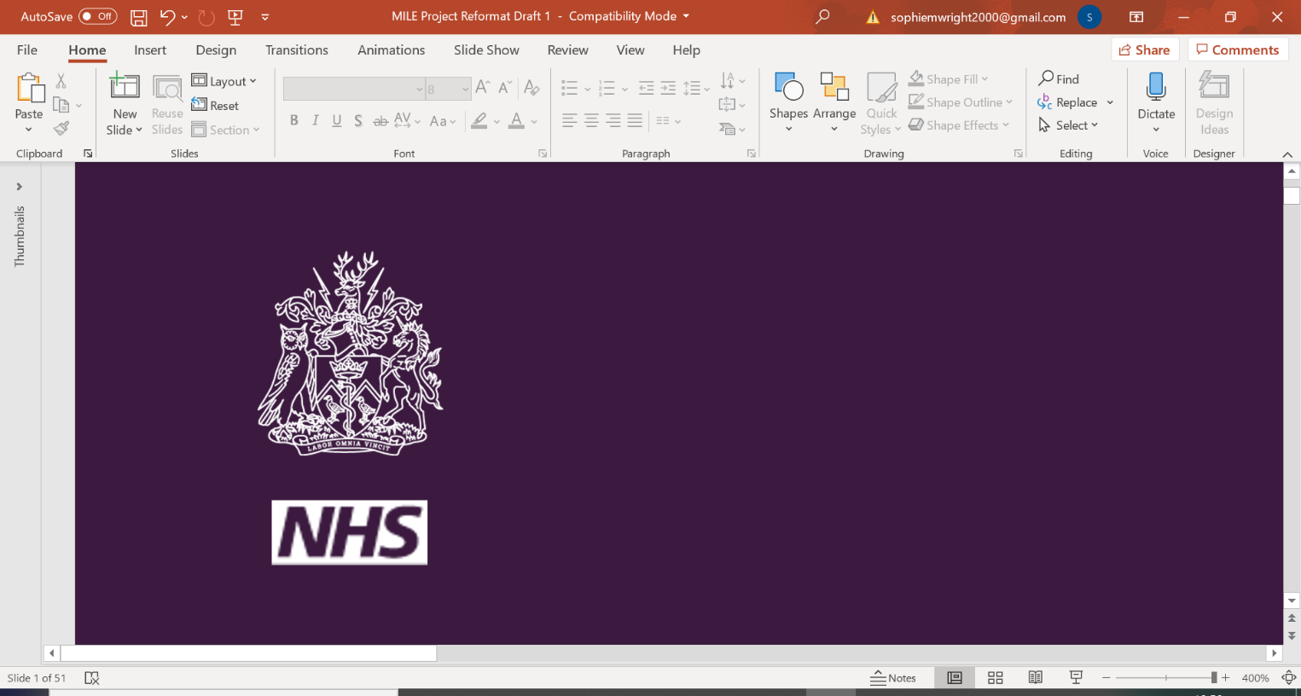

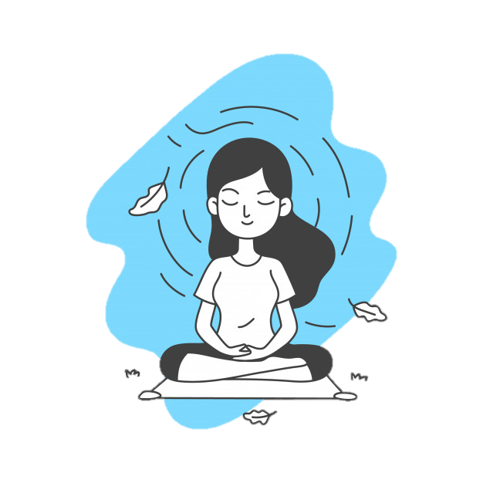*Mindful Relaxing Exercise Script*

(Paul Gilbert – The Compassionate Mind, p.259)

Make yourself comfortable in your chair. Feet flat on the floor is usually practiced as this gives a sense of grounding by connection. Similarly, eyes closed or open would be useful to think about - giving permission for your eyes to be open but gaze softened and lowered can be useful. Arms resting gently, hands on the lap. Being aware of the position of the spine - we usually advocate comfort but with a posture that pays attention to preserving the curves of the spine.

Then focus on your breathing until you find the rhythm that feels most comfortable and soothing to you. If this seems hard, don’t worry: just breath in the most comfortable and natural way you can. Spend about 30 seconds finding your rhythm – longer, if you wish.

As we do this exercise, you may notice your mind wanders off in different directions. It could be thoughts about things that have happened in the past, worries about the future, sensations going on inside your body, noises going on inside or outside the room. If you notice this happening, that’s okay. Just gradually bring your attention back to your body and the instructions of the exercise.

When you’ve done that, I would like you to focus on your legs and feet: notice how they feel. Then imagine all of the tension flowing down through your legs, and down into the floor and away. Let it go on its way. …/… Sometimes people find it helpful to slightly tense their muscles as they breathe in, and then relax them as they breathe out. Just spend 30 seconds now letting the tension go …

Now focus on your upper body and feel the tension in it from your shoulders down to your trunk. As you breathe out, just imagine the tension leaving this part of your body, going down through your pelvis, going down through your legs, down through the floor and away. If it helps, gently tense your stomach and back muscles as you breathe in, and then relax as you breathe out.

Now focus on the tips of your fingers and up through your wrists, forearms, elbows, upper arms and shoulders. Imagine that any tension there can be released – that you can let go of it. Gently let the tension go so that it can run off through your body, down through your legs and out through the floor, away.

Now imagine the tension that sits in your head and in your neck. It has been your alert system and it would like to be released now – to take a rest. So again, as you breathe out, just imagine it running down through your body, through your legs and out through the floor.

Now we can focus on your whole body. Each time you exhale, think of the word ‘relax’. Just imagine your body becoming more and more relaxed. Spend a minute or so doing this.

To wrap up this exercise, take a deeper breath, move around a little, stretch out your arms. Notice how your body feels after you have spent a little time letting go of the tension. You can practice this exercise as often as you find helpful. It can also make it easier to sleep.



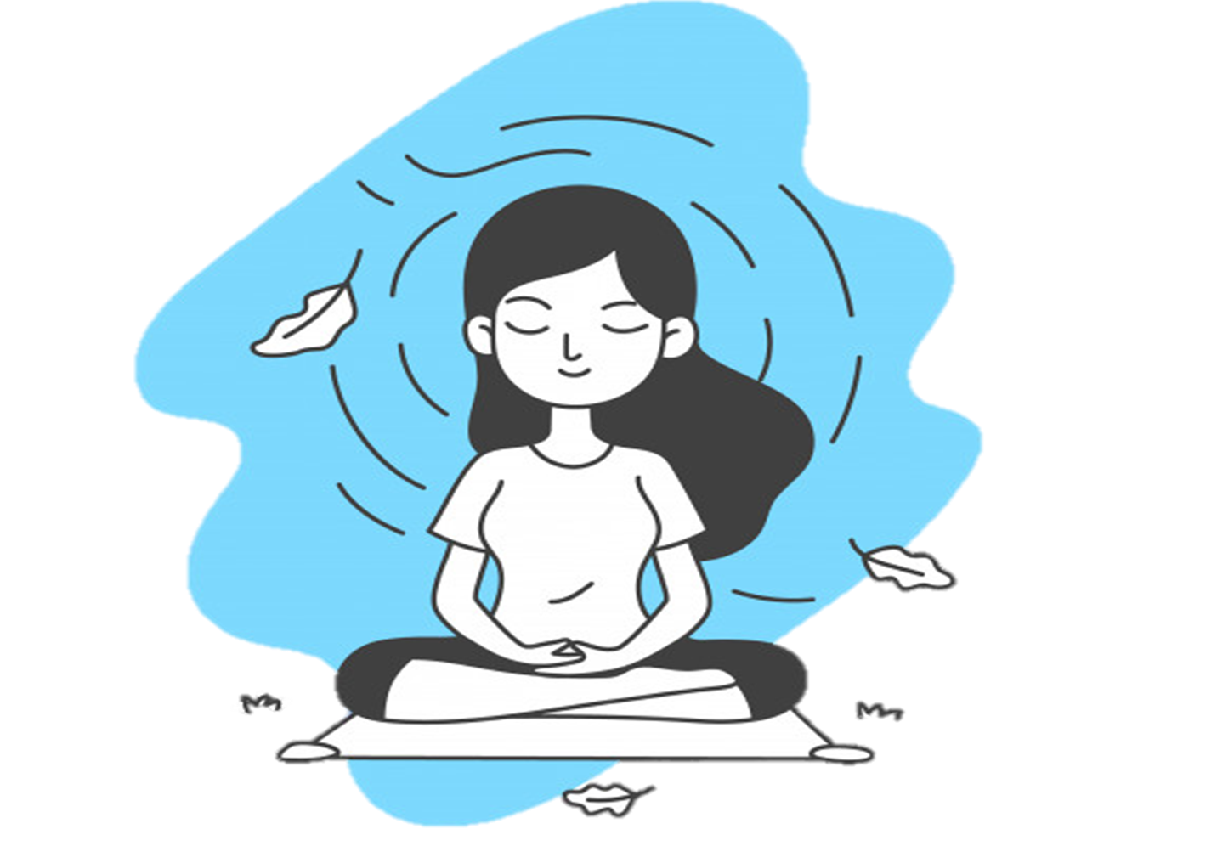

*Mindful Relaxing Exercise – Self Reflection*

Take a few minutes to think about what the exercise was like for you. You might like to write down the answers to these questions:

What was that exercise/experience like for you?

What impact did this exercise have on your body? Thoughts?

What did you notice? Where did you notice your attention going in the exercise?

How might this be useful for you in your broader life?

What would regular practice of this be like? How can you incorporate this into daily life?